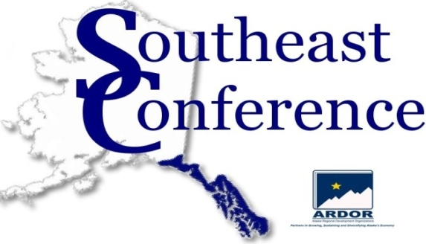
P.O. Box 21989
612 W. Willoughby Avenue, Suite B
Juneau, AK 99802
(907) 523-4353
(907) 463-5670 fax
www.seconference.org

FY12 Membership Information

Organization: __________________
Mailing Address: ___________________
City/State/Zip: ___________________
Phone: Fax:______________________Website:_______________
Chief Executive: ___________________ Title: _________
Point of Contact: _________
Title: Email: ___________________
Mailing Address (if different than above): __________________
City/State/Zip: ___________________
Phone: Fax: __________________________________ Cell:
Info provided by: ____________________________________ Date: _____________________________________

Membership Category
(please circle)

Associate $165
Municipality $330
Individual $330
Business
Single-sited $330
Multi-sited $660
State-wide $1,320
Multi-state $1,980
Major Corporations $1,980
Non-Profit
Single-sited $330
State-wide $660
State or Federal Government Agency $330
Federally-Recognized Tribe $330
Chamber of Commerce $330
Municipalities *contact SEC office for details.

Payment

Amount $ (circle one) Check Enclosed Credit Card: Visa MC Amex/Discover

Card Number: ___________ _________ ___________Expiration Date: 3 Digit Identifier: _________

Statement Zip Code: Authorized Signature: _ Date: _________ _______

Membership Committee Participation
Other individuals who will be representing and participating in committees on behalf of your organization:

Name: Title:
Email: Phone: _________
Receive Email Newsletter: Yes No

Name: Title:
Email: Phone: _________
Receive Email Newsletter: Yes No

Name: Title:
Email: Phone: _________
Receive Email Newsletter: Yes No

Name: Title:
Email: Phone: _________
Receive Email Newsletter: Yes No

Name: Title:
Email: Phone: _________
Receive Email Newsletter: Yes No

Name: Title:
Email: Phone: _________
Receive Email Newsletter: Yes No

Committees & Sub-Committees
Please check any committees you would like your organization to participate in.

Energy Health, Education, & Social Services Workforce Devel.
Environment Timber
Communications Tourism
Transportation Economic Development
Fisheries Mining

